Axiom Requisition Copy Service
2869 Jolly Road, Okemos, Michigan 48864
517.886.5099 – 877.886.5090 toll free – 517.886.4116 facsimile

IRS AUTHORIZATION INSTRUCTIONS

Due to Disclosure laws the IRS requires their authorization form be completed with specific information. To avoid the authorization from being rejected we ask that you fill in the following information below. We will transfer this information to the IRS authorization. The attached IRS authorization must be signed by the taxpayer and if filed jointly, the spouse must sign as well. Return this instruction form along with the ORIGINAL signed IRS authorization to our office.

Full Taxpayer Name: ___________________________________________________
If filed jointly, Full Name of Spouse:
___________________________________________________
Full Taxpayer Social Security Number:
___________________________________________________
If filed jointly, Full Social Security Number of Spouse: ___________________________________________________

Please note one of the addresses you list below must match what the IRS has on file. So you may need to refer to your last income tax return to confirm the correct address to enter below.

Current Taxpayer Address on File with IRS (you may need to contact the IRS to confirm which address they have on file:
Street Address: _________________________________________________________
City, State & Zip: _______________________________________________________

All Previous Taxpayer Addresses for the last seven years:
Street Address: _________________________________________________________
City, State & Zip: _______________________________________________________
Street Address: _________________________________________________________
City, State & Zip: _______________________________________________________
Street Address: _________________________________________________________
City, State & Zip: _______________________________________________________
Street Address: _________________________________________________________
City, State & Zip: _______________________________________________________

Order No. 01-30154-008
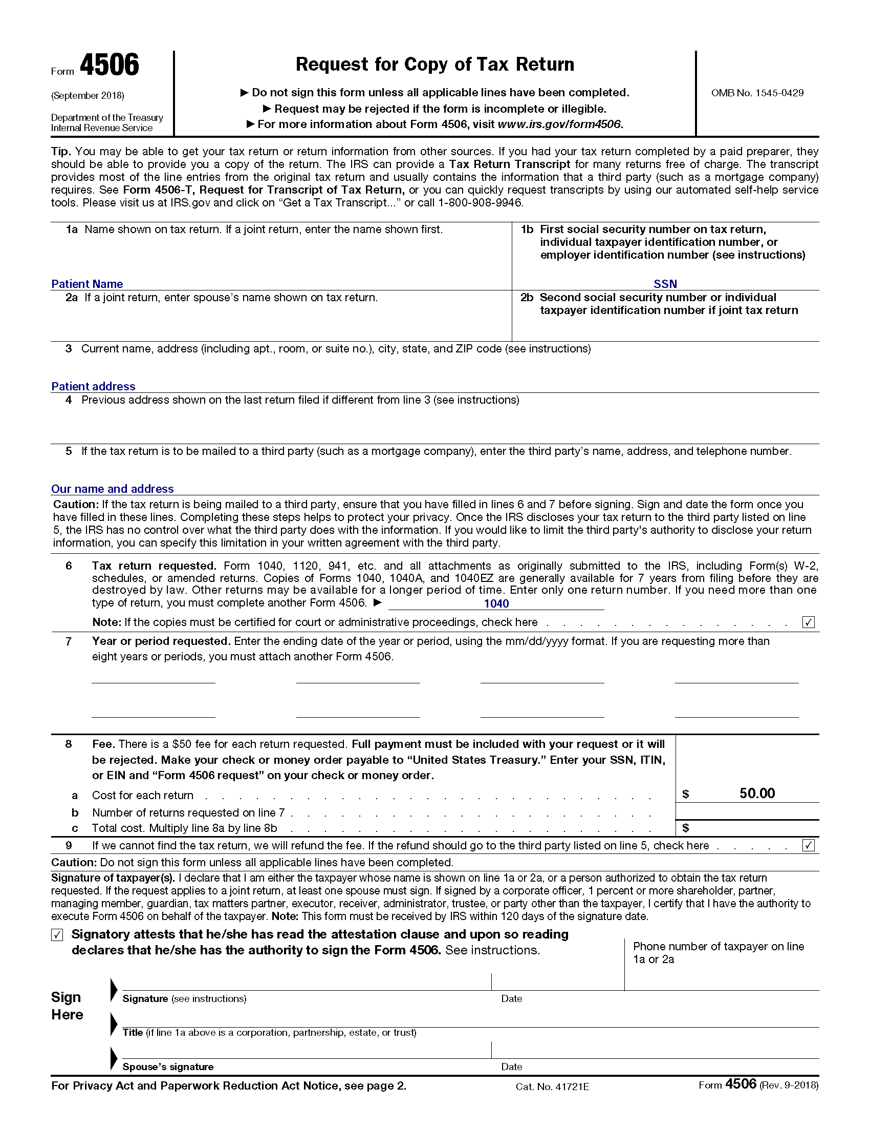
Nikolay Novosseletz
,

Axiom Requisition Copy Service, 2869 Jolly Road, Okemos, Michigan 48864
(877) 886-5090 (517) 886-4116 Fax
1040
***If copies are unavailable for any of the years we are requesting, please send transcripts***
X
X
Order No. 01-30154 - 008

«Year1»
«Year5»
«Year4»
«Year8»
«Year3»
«Year2»
«Year6»
«Year7»

«Total_Cost»
X

